Workshop « Joint France-Japan Symposium on Circularly Polarized Luminescence and Related Phenomena »

November 13, 2023

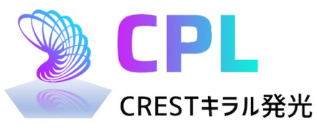







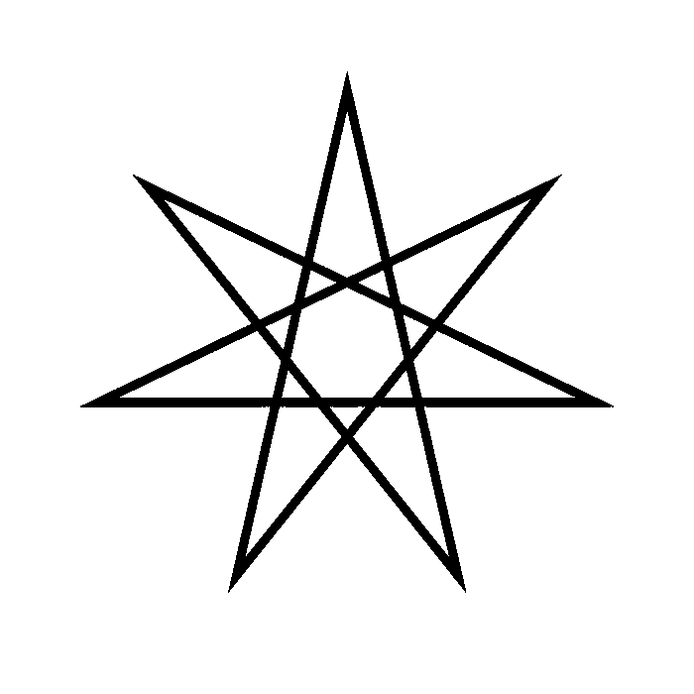
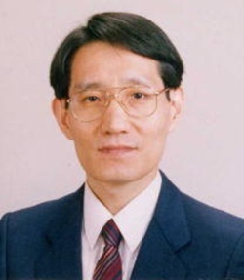
Kazuo Akagi
Research Organization of Science and Technology, Ritsumeikan University
Polymer Chemistry, Materials Chemistry, Liquid Crystal Chemistry

https://www.ritsumei.ac.jp/~akagi/akagi_hp_2014_ritsumei/akagi_hp-english/research.html

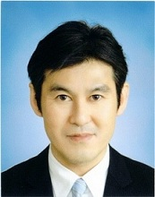
Hiroyuki NISHIKAWA
Professor, Graduate School of Science and Engineering, Department of Science, Ibaraki University

Physical Chemistry, Molecular Conductors, Organic Semiconductors, Organic Devices
http://www.gse.ibaraki.ac.jp/common/research/pdf/308_NishikawaHiroyuki.pdf
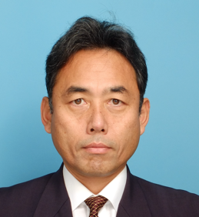
Shigeyuki YAGI
Professor, Osaka Metropolitan University, Graduate School of
Engineering Division of Science and Engineering for Materials, Chemistry and Biology

Functional Dyes, Materials for Organic Light-Emitting Diodes
http://www2.chem.osakafu-u.ac.jp/ohka/ohka6/indexe.html

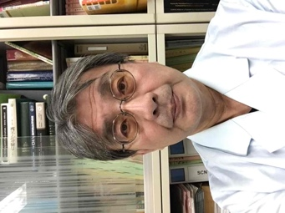
Ken-ichi SUGIURA
Tokyo Metropolitan University, Graduate School of Science, Department of Chemistry

Physical Chemistry, Molecular Conductors, Organic Semiconductors, Organic Devices

https://researchmap.jp/pyrene?lang=en

Planning of the November 13th
08:50 | opening
09:10 | Kazuo Akagi | Synthesis and Chiroptical Properties of Helical Conjugated Polymers
09:40 | Céline Olivier | Design and Chiroptical Studies of Helically Chiral Molecular and Supramolecular systems
10:05 | Yann Ferrand | Probing chirality in host-guest recognition events
10:30 | coffee break
11:00 | Hiroyuki NISHIKAWA | Development of AIE-active CPL materials and their light-emitting devices
11:30 | Dario Bassani | Harnessing excited-state symmetry breaking and supramolecular interactions for efficient CPL materials
11:55 | Emilie Pouget | Design of functional nanostructures via chirality induction: towards magnetochiral dichroism
12:10 | Sylvain Nlate | Cobalt bis(dicarbollide)-based silica nanohelices: Innovative chiral photoredox catalysts for asymmetric oxidaton in water
12:25 | Lunch
14:00 | Ken-ichi SUGIURA | Visualization of Electronic and Magnetic Electronic and Magnetic Transition Moments Aiming at the Design of CPL Chromophore Having Enhanced Chiroptical Properties
14:30 | Laurent Bouffier | Molecular Aspects of Electrogenerated Chemiluminescence: From Novel Active Dyes to Chiroptical Probes
14:55 | Elizabeth Hillard
15:15 | Shigeyuki YAGI | Magnetically Driven Circularly Polarized Electroluminescence Devices Based on Phosphorescent Organometallic Complexes
15:45 | Vincent Rodriguez | Second-Order Non Linear Optical/Magneto-optical Techniques: Towards Efficient Chiroptical Techniques
16:10 | Reiko Oda | Transferring Chiral Information between Objects with different dimensions
16:30 | closing
20:00 | diner

